**Ozil:**

**Testing and Inspection Report**



# *Prepared by*

**Nivetha Babu**

**Alexander Moreno**

**Nguyen Vu**

**Linda Zhou**

**for use in**

**CS 440 at the**

**University of Illinois Chicago**

# September 2018

# Table of Contents

REMOVE OR REPLACE ALL TEXT IN RED ITALICS BEFORE SUBMITTING REPORT........................................................................................................................... 2

How to Use This Document .............................................................................................. 2

List of Figures ................................................................................................................... 6

List of Tables .................................................................................................................... 7

1. Project Description ........................................................................................................... 8
   1. Project Overview .............................................................................................................. 8
   2. Project Domain ................................................................................................................. 8
   3. Relationship to Other Documents .................................................................................... 8
   4. Naming Conventions and Definitions .............................................................................. 8 4a Definitions of Key Terms ......................................................................................... 8

4b UML and Other Notation Used in This Document ............................................. 10

4c Data Dictionary for Any Included Models ............................................................. 10

1. Testing ............................................................................................................................ 11
   1. Items to be Tested ........................................................................................................... 11
   2. Test Specifications .......................................................................................................... 11
   3. Test Results .................................................................................................................... 12
   4. Regression Testing ......................................................................................................... 13
2. Inspection ....................................................................................................................... 13
   1. Items to be Inspected ...................................................................................................... 13
   2. Inspection Procedures ..................................................................................................... 13
   3. Inspection Results ........................................................................................................... 13
3. Reccomendations and Conclusions ................................................................................ 13
4. Project Issues .................................................................................................................. 14
   1. Open Issues ..................................................................................................................... 14
   2. Waiting Room ................................................................................................................ 14
   3. Ideas for Solutions .......................................................................................................... 15
   4. Project Retrospective ...................................................................................................... 16 VI Glossary .......................................................................................................................... 16
5. References / Bibliography .............................................................................................. 17
6. Index ............................................................................................................................... 17

## List of Figures

## 

Figure 1. This use case diagram shows Product Use Case List key use cases, such as registering User, logging into Account, creating User Story, creating Task for the use cases, logging Defect, triaging the defect, and generating the report.

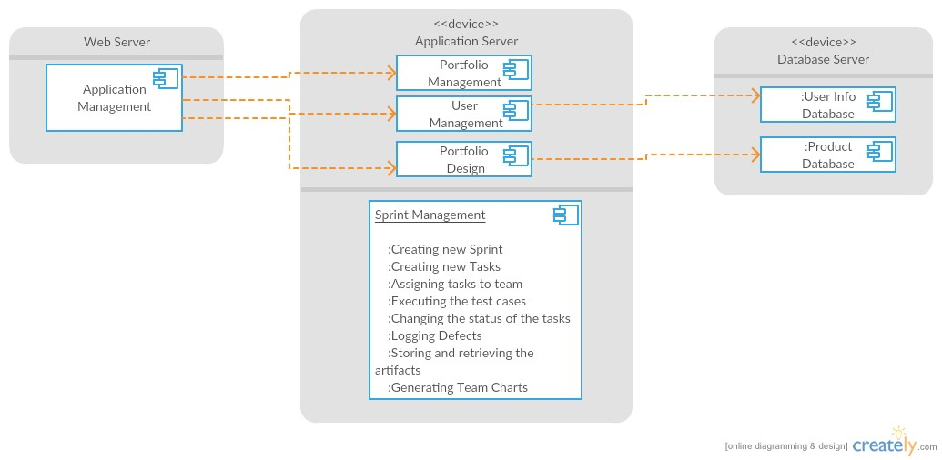

Figure 2. The product Ozil is built upon a web server. The server will be responsible for storing the information of the user and the storage of the artifact repository. Image is provided by original creators of Ozil, Vinit Kumar, Omaid Khan, Filip Variciuc, Jesus Solorzano.

## I Project Description

### 1 Project Overview

Every company’s employees deserve innovative and hyper-intuitive ways to plan, track, and collaborate with each other. That’s where Ozil comes in. Ozil is a groundbreaking package tool to help companies of every kind to accelerate every team to unleash their full potential, remotely, face-to-face, or otherwise. Tools and information in one team can become accessible across the various departments, time zones, and job titles of the company. The information you need is at your fingertips.

The Ozil software offers many tools to the user, whether a new user or a seasoned one. These tools can be further used to create stories, create tasks within those stories, then assign those tasks to different team members, update the status of those tasks, log/assign defects to a resource and triage the defect for a particular sprint. There will be a centralized database that will store all such data pertaining to each user for each task in a sprint. A burndown/burnup report would be generated at the end of each sprint.

### 2 Project Domain

Ozil acts as a collaboration and project management service for businesses and individuals alike to help users stay better organized and informed. The home page serves as the central hub, showing users all of their boards and tasks. The product Ozil is built upon a web server. The server will be responsible for storing the information of the user and the storage of the artifact repository, as shown in Figure 2.

### 3 Relationship to Other Documents

Along with the Project Description Document, Project Requirements, and Product Design Document, the Testing and Inspection report details the unit test and inspection spring for Ozil. Each member of our team has contributed significant pieces of code that is submitted for execution and inspection. The Testing and Inspection report not only provides test suites for each piece of tested code, but also reports the results of conducting the tests, results of inspecting the code, and a conclusion of our finding.

### 

### 4 Naming Conventions and Definitions

#### 4a Definitions of Key Terms

|  |  |
| --- | --- |
| Key Term | Definition |
| SYSADMIN | System administrator is the one who grants access to all applications, their administration features and Site administration, which includes managing users  and bills |
| Admin | Administrator is the one who grants access to all applications and their administration features (excluding Site administration) |
| User | The customer or group of customers who are using the software. |
| Dashboard | The page where the user is able to check the tasks that are currently in his  plate. |
| Projects | The page where the user can see and manage the task of single or multiple  projects. |
| Issues | The Product backlog item or defect that is been created for the current sprint. |
| Story | The summary of the PBI or defect of the current issue. |
| Priority | The urgency or severity of the task or the defect (High, Medium, Low). |
| Edit | Modify the current task. |
| Assign | Assign the task to the available resource. |
| Log Defect | Bug found in task. User submits a description of the defect. |

#### 4b UML and Other Notation Used in This Document

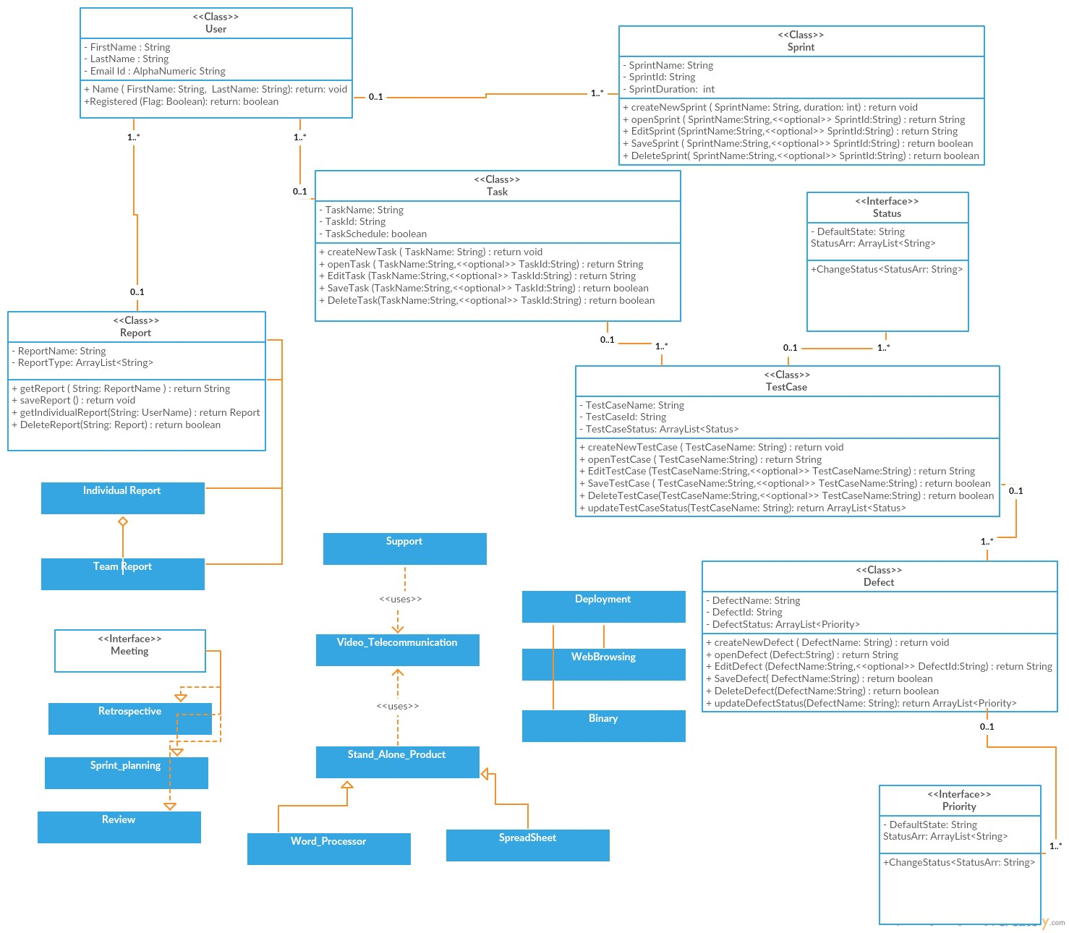

Figure 3. UML Diagram created by creators of Ozil, Vinit Kumar, Omaid Khan, Filip Variciuc, Jesus Solorzano.

#### 4c Data Dictionary for Any Included Models

**Successful Login:**

When the user is successfully able to login to the system.

**Sprint**:

Beginning of the sprint cycle for the current project **Task**:

Each sprint has multiple tasks and are assigned to different team members to work upon.

**TestCases**:

Each task can be subdivided into multiple user stories and from thereon to multiple test cases. These test cases are created by the user.

**Scheduling of Task:**

To divide or distribute the task amongst different team members

**Defect Creation:**

To create defect for each failed test case and providing steps to repro the defect.

**Triaging of Defect:**

To distribute the defect amongst the team members and work upon it checking the severity and priority of the defect.

**Team Meetings:**

The different team meetings the user will be participant of throughout the sprint.

**BurnDown Report:**

The activity or effort over time report of either each individual or the entire team for the entire sprint.

## II Testing

### 5 Items to be Tested

|  |  |
| --- | --- |
| **Item ID** | **Description** |
| A | New user sign up. |
| B | Returning user logs in. |
| C | User create user story. |
| D | User create task for each user stories. |
| E | User assigns duration on task. |
| F | User moves the task across various stages. |
| G | User logs in as manager and checks for story report. |
| H | User checks defect log. |
| I | User submits a defect. |

### 6 Test Specifications

|  |  |
| --- | --- |
| ID# - A | |
| **Description** | New user sign up. |
| **Items covered by this test** | A new user creates an account on Ozil. User must have First Name, Last Name, and an unique username/password combination. |
| **Requirements addressed by this test** | N/A |
| **Environmental needs** | Hardware options:   * Dell PowerEdge Servers      * HP Server DL380p and ML350p      * Microsoft Surface Pro 3 and 4 * Apple MacBook Pro * Amazon AWS Servers * Microsoft Azure Cloud Servers     Software options:   * OS-X Maverick * OS-X Yosemite * OS-X El Capitan * Windows 7 Pro * Windows 8.1 Pro * Windows 10 Pro * Ubuntu 14.04 LTS * Linux Mint 17.2 Rafaela |
| **Intercase Dependencies** | Local host is up and running. |
| **Test Procedures** | User clicks link “Create account.”  User fills in all required fields and clicks done. |
| **Input Specifications** | User is on the home screen and is a new user. |
| **Output Specifications** | User’s information is added to the user database and the user is brought to their portfolio page. |
| **Pass/Fail Criteria** | Fail: User is unable to sign up for an account.  Any deviation from the expected results will be considered a failure of that test.  Pass: A test will be considered a pass if and only if the actual results of the test match the expected results specified in the associated test case. Successful account creation will pass when it has been subjected to all associated test cases and passes at least 99 percent of the time. Anything less will call for debugging of the associated code. |

|  |  |
| --- | --- |
| ID# - B | |
| **Description** | Returning user logs in. |
| **Items covered by this test** | Registered users can log into Ozil, provided correct username and password. |
| **Requirements addressed by this test** | N/A |
| **Environmental needs** | Hardware options:   * Dell PowerEdge Servers      * HP Server DL380p and ML350p      * Microsoft Surface Pro 3 and 4 * Apple MacBook Pro * Amazon AWS Servers * Microsoft Azure Cloud Servers     Software options:   * OS-X Maverick * OS-X Yosemite * OS-X El Capitan * Windows 7 Pro * Windows 8.1 Pro * Windows 10 Pro * Ubuntu 14.04 LTS * Linux Mint 17.2 Rafaela |
| **Intercase Dependencies** | Test A must be completed successfully before Test B to run. |
| **Test Procedures** | User clicks sign up.  User leaves one or more required fields blank and clicks done.  User clicks Login.  User enters a valid username and password. |
| **Input Specifications** | User is on the home screen and is a new user.  User is on the home screen and has an account. |
| **Output Specifications** | A dialogue highlighting the missing information is displayed. Info is not added to the database.  The user is logged in and brought to their portfolio page.  The user is prompted that they have entered an invalid username or password. |
| **Pass/Fail Criteria** | Fail: Returning User is unable to sign into their Ozil account.  Any deviation from the expected results will be considered a failure of that test.  Pass: A test will be considered a pass if and only if the actual results of the test match the expected results specified in the associated test case. Successful account login will pass when it has been subjected to all associated test cases and passes at least 99 percent of the time. Anything less will call for debugging of the associated code. |

|  |  |
| --- | --- |
| ID# - C | |
| **Description** | User create user story. |
| **Items covered by this test** | User has successfully logged in the application, and is ready to create a story card. |
| **Requirements addressed by this test** | N/A |
| **Environmental needs** | Hardware options:   * Dell PowerEdge Servers      * HP Server DL380p and ML350p      * Microsoft Surface Pro 3 and 4 * Apple MacBook Pro * Amazon AWS Servers * Microsoft Azure Cloud Servers     Software options:   * OS-X Maverick * OS-X Yosemite * OS-X El Capitan * Windows 7 Pro * Windows 8.1 Pro * Windows 10 Pro * Ubuntu 14.04 LTS * Linux Mint 17.2 Rafaela |
| **Intercase Dependencies** | Test A and Test B must be completed successfully before Test C to run. |
| **Test Procedures** | User clicks on create New User Story link.  User enters the name of the user story and clicks on Save button.  User clicks on one of the user story that has been created by User or other team member. |
| **Input Specifications** | User has successfully logged in the application |
| **Output Specifications** | The user story is saved in the system and is displayed under the User Stories tab.  The user story is shown on the screen and displays the details of the user story. |
| **Pass/Fail Criteria** | Fail: User is unable to create user story.  Any deviation from the expected results will be considered a failure of that test.  Pass: A test will be considered a pass if and only if the actual results of the test match the expected results specified in the associated test case. Successful user story creation will pass when it has been subjected to all associated test cases and passes at least 99 percent of the time. Anything less will call for debugging of the associated code. |

|  |  |
| --- | --- |
| ID# - D | |
| **Description** | User create task for each user stories. |
| **Items covered by this test** | After creating a story, user has chance to create tasks for each user story. |
| **Requirements addressed by this test** | N/A |
| **Environmental needs** | Hardware options:   * Dell PowerEdge Servers      * HP Server DL380p and ML350p      * Microsoft Surface Pro 3 and 4 * Apple MacBook Pro * Amazon AWS Servers * Microsoft Azure Cloud Servers     Software options:   * OS-X Maverick * OS-X Yosemite * OS-X El Capitan * Windows 7 Pro * Windows 8.1 Pro * Windows 10 Pro * Ubuntu 14.04 LTS * Linux Mint 17.2 Rafaela |
| **Intercase Dependencies** | Test C must be completed successfully before Test D to run. |
| **Test Procedures** | User creates new task for the user story.  User clicks on create New Task link.  User enters the name of the task and clicks on  Save button  User assigns the task to any of the team member.  User reassigns the task to any of the team member other than the user was previously assigned to. |
| **Input Specifications** | User has successfully logged in the application and has created user story. |
| **Output Specifications** | The new Task is created for the user and members of the Team are able to view new Tasks on the My Task screen under the user story section. |
| **Pass/Fail Criteria** | Fail: User is unable to create task for each user story. Any deviation from the expected results will be considered a failure of that test.  Pass: A test will be considered a pass if and only if the actual results of the test match the expected results specified in the associated test case. Successful user task creation for respective user story will pass when it has been subjected to all associated test cases and passes at least 99 percent of the time. Anything less will call for debugging of the associated code. |

|  |  |
| --- | --- |
| ID# - E | |
| **Description** | User assigns duration on task. |
| **Items covered by this test** | User can give a time window for each task. A start date and end date is submitted by User. |
| **Requirements addressed by this test** | N/A |
| **Environmental needs** | Hardware options:   * Dell PowerEdge Servers      * HP Server DL380p and ML350p      * Microsoft Surface Pro 3 and 4 * Apple MacBook Pro * Amazon AWS Servers * Microsoft Azure Cloud Servers     Software options:   * OS-X Maverick * OS-X Yosemite * OS-X El Capitan * Windows 7 Pro * Windows 8.1 Pro * Windows 10 Pro * Ubuntu 14.04 LTS * Linux Mint 17.2 Rafaela |
| **Intercase Dependencies** | Test C and Test D must be completed successfully before Test E to run. |
| **Test Procedures** | User creates new task for the user story.  User assigns the task to any of the team member. |
| **Input Specifications** | User has successfully logged in the application and has created user story. |
| **Output Specifications** | The task should be assigned to the respective  team member and should show up new task for that team member. |
| **Pass/Fail Criteria** | Fail: User is unable to assign a time duration to task. Any deviation from the expected results will be considered a failure of that test.  Pass: A test will be considered a pass if and only if the actual results of the test match the expected results specified in the associated test case. Successful duration assignment to task will pass when it has been subjected to all associated test cases and passes at least 99 percent of the time. Anything less will call for debugging of the associated code. |

|  |  |
| --- | --- |
| ID# - F | |
| **Description** | User moves the task across various stages. |
| **Items covered by this test** | User can move task from To-Do, In-Progress, or Done columns. |
| **Requirements addressed by this test** | N/A |
| **Environmental needs** | Hardware options:   * Dell PowerEdge Servers      * HP Server DL380p and ML350p      * Microsoft Surface Pro 3 and 4 * Apple MacBook Pro * Amazon AWS Servers * Microsoft Azure Cloud Servers     Software options:   * OS-X Maverick * OS-X Yosemite * OS-X El Capitan * Windows 7 Pro * Windows 8.1 Pro * Windows 10 Pro * Ubuntu 14.04 LTS * Linux Mint 17.2 Rafaela |
| **Intercase Dependencies** | Test C must be completed successfully before Test F to run. |
| **Test Procedures** | User moves the task from “To-Do” to “In  Progress” |
| **Input Specifications** | User has already created user stories and have assigned certain tasks in the user stories to respective team members. |
| **Output Specifications** | The task card is moved to “In Progress” state.  Accordingly, the task status is updated to the new state.  The same status is reported in the burndown chart. |
| **Pass/Fail Criteria** | Fail: User is unable to move the task across story stages. Any deviation from the expected results will be considered a failure of that test.  Pass: A test will be considered a pass if and only if the actual results of the test match the expected results specified in the associated test case. Successful movement of tasks across story stages will pass when it has been subjected to all associated test cases and passes at least 99 percent of the time. Anything less will call for debugging of the associated code. |

|  |  |
| --- | --- |
| ID# - G | |
| **Description** | User logs in as manager and checks for story report. |
| **Items covered by this test** | Registered Users can log in as manager status to check reports on stories. |
| **Requirements addressed by this test** | N/A |
| **Environmental needs** | Hardware options:   * Dell PowerEdge Servers      * HP Server DL380p and ML350p      * Microsoft Surface Pro 3 and 4 * Apple MacBook Pro * Amazon AWS Servers * Microsoft Azure Cloud Servers     Software options:   * OS-X Maverick * OS-X Yosemite * OS-X El Capitan * Windows 7 Pro * Windows 8.1 Pro * Windows 10 Pro * Ubuntu 14.04 LTS * Linux Mint 17.2 Rafaela |
| **Intercase Dependencies** | Test B must be completed successfully before Test G to run. |
| **Test Procedures** | The manager has clicked on the report tab.  The manager clicks on the burnup report tab. |
| **Input Specifications** | The manager has logged in the system. |
| **Output Specifications** | The burnup tab is displayed on the screen and show the efforts made by each resource in the current sprint. |
| **Pass/Fail Criteria** | Fail: User is unable to log in as manager and check story report. Any deviation from the expected results will be considered a failure of that test.  Pass: A test will be considered a pass if and only if the actual results of the test match the expected results specified in the associated test case. Successful manager login and report check-in will pass when it has been subjected to all associated test cases and passes at least 99 percent of the time. Anything less will call for debugging of the associated code. |

|  |  |
| --- | --- |
| ID# - H | |
| **Description** | User checks defect log. |
| **Items covered by this test** | Registered Users can check table of defects submitted by team. |
| **Requirements addressed by this test** | N/A |
| **Environmental needs** | Hardware options:   * Dell PowerEdge Servers      * HP Server DL380p and ML350p      * Microsoft Surface Pro 3 and 4 * Apple MacBook Pro * Amazon AWS Servers * Microsoft Azure Cloud Servers     Software options:   * OS-X Maverick * OS-X Yosemite * OS-X El Capitan * Windows 7 Pro * Windows 8.1 Pro * Windows 10 Pro * Ubuntu 14.04 LTS * Linux Mint 17.2 Rafaela |
| **Intercase Dependencies** | Test C must be completed successfully before Test H to run. |
| **Test Procedures** | The user clicks on link to create new defect for the test case that has failed.  The user is presented with log new defect screen.  The user enters the steps to repro the defect and attaches the screen shot and video to repro the defect.  The user assigns the defect to the developer after assigning it severity and priority.  The user submits the defect. |
| **Input Specifications** | User has executed the test cases and has marked some of the test cases as fail. |
| **Output Specifications** | Defect is reported. |
| **Pass/Fail Criteria** | Fail: User is unable to check defect log.  Any deviation from the expected results will be considered a failure of that test.  Pass: A test will be considered a pass if and only if the actual results of the test match the expected results specified in the associated test case. Successful check in for defect log will pass when it has been subjected to all associated test cases and passes at least 99 percent of the time. Anything less will call for debugging of the associated code. |

|  |  |
| --- | --- |
| ID# - I | |
| **Description** | User submits a defect. |
| **Items covered by this test** | Registered Users witnesses a defect during course of the project. User can submit an account of the defect. |
| **Requirements addressed by this test** | N/A |
| **Environmental needs** | Hardware options:   * Dell PowerEdge Servers      * HP Server DL380p and ML350p      * Microsoft Surface Pro 3 and 4 * Apple MacBook Pro * Amazon AWS Servers * Microsoft Azure Cloud Servers     Software options:   * OS-X Maverick * OS-X Yosemite * OS-X El Capitan * Windows 7 Pro * Windows 8.1 Pro * Windows 10 Pro * Ubuntu 14.04 LTS * Linux Mint 17.2 Rafaela |
| **Intercase Dependencies** | Test C must be completed successfully before Test I to run. |
| **Test Procedures** | User enters his comments in the validation comments box.  User saves his comments.  User changes the status of the defect from open to fix  validated(environment)->fixed->closed |
| **Input Specifications** | User logged the defect. |
| **Output Specifications** | The defect status along with comments should be appropriately updated. |
| **Pass/Fail Criteria** | Fail: User is unable to submit a defect to defect log. Any deviation from the expected results will be considered a failure of that test.  Pass: A test will be considered a pass if and only if the actual results of the test match the expected results specified in the associated test case. Successful user defect submission will pass when it has been subjected to all associated test cases and passes at least 99 percent of the time. Anything less will call for debugging of the associated code. |

### 7 Test Results

|  |  |
| --- | --- |
| ID# - A | |
| **Date(s) of Execution** | 11/22/18 |
| **Staff conducting tests** | Linda Zhou, Nivetha Babu |
| **Expected Results** | New user creates a new account. New user is added into database. |
| **Actual Results** | New user creates a new account. New user is added into database. |
| **Test Status** | Pass |

|  |  |
| --- | --- |
| ID# - B | |
| **Date(s) of Execution** | 11/22/18 |
| **Staff conducting tests** | Linda Zhou, Alexander Moreno |
| **Expected Results** | Returning user successfully logs into Ozil account. |
| **Actual Results** | Returning user successfully logs into Ozil account. |
| **Test Status** | Pass |

|  |  |
| --- | --- |
| ID# - C | |
| **Date(s) of Execution** | 11/22/18 |
| **Staff conducting tests** | Linda Zhou, Nivetha Babu |
| **Expected Results** | User creates story on Ozil. |
| **Actual Results** | User logs in. User selects create story on Ozil dashboard. User is able to submit the story. |
| **Test Status** | Pass |

|  |  |
| --- | --- |
| ID# - D | |
| **Date(s) of Execution** | 11/24/18 |
| **Staff conducting tests** | Linda Zhou, Nivetha Babu |
| **Expected Results** | User creates task on Ozil. |
| **Actual Results** | User logs in. User selects story on Ozil dashboard. User is able to submit a task to specific story. |
| **Test Status** | Pass |

|  |  |
| --- | --- |
| ID# - D | |
| **Date(s) of Execution** | 11/24/18 |
| **Staff conducting tests** | Linda Zhou, Nivetha Babu |
| **Expected Results** | User creates more than one task on Ozil. |
| **Actual Results** | User logs in. User selects story on Ozil dashboard. User is able to submit a task to specific story. User is able to submit a second task to specific story. User is able to submit a third task to specific story. |
| **Test Status** | Pass |

|  |  |
| --- | --- |
| ID# - D | |
| **Date(s) of Execution** | 11/24/18 |
| **Staff conducting tests** | Linda Zhou, Nivetha Babu |
| **Expected Results** | User can delete a newly created task on Ozil. |
| **Actual Results** | User logs in. User selects story on Ozil dashboard. User is able to submit a task to specific story. Glitch in deleting a task from story board. |
| **Test Status** | Fail |

|  |  |
| --- | --- |
| ID# - D | |
| **Date(s) of Execution** | 11/24/18 |
| **Staff conducting tests** | Linda Zhou, Nivetha Babu |
| **Expected Results** | User creates more than one task on Ozil. |
| **Actual Results** | User logs in. User selects story on Ozil dashboard. User is able to submit a task to specific story. User is able to submit a second task to specific story. User is able to submit a third task to specific story. |
| **Test Status** | Pass |

|  |  |
| --- | --- |
| ID# - E | |
| **Date(s) of Execution** | 11/24/18 |
| **Staff conducting tests** | Linda Zhou, Nivetha Babu |
| **Expected Results** | User assigns duration on task. |
| **Actual Results** | User logs in. User selects story on Ozil dashboard. User is able to submit a task to specific story. User assigns duration on task. |
| **Test Status** | Pass |

|  |  |
| --- | --- |
| ID# - F | |
| **Date(s) of Execution** | 11/24/18 |
| **Staff conducting tests** | Linda Zhou, Nivetha Babu |
| **Expected Results** | User moves the task across various stages. |
| **Actual Results** | User logs in. User selects story on Ozil dashboard. User selects a task within story. User designates the task as To-Do. |
| **Test Status** | Pass |

|  |  |
| --- | --- |
| ID# - F | |
| **Date(s) of Execution** | 11/24/18 |
| **Staff conducting tests** | Linda Zhou, Nivetha Babu |
| **Expected Results** | User moves the task across various stages. |
| **Actual Results** | User logs in. User selects story on Ozil dashboard. User selects a task within story. User designates the task as In-Progress. |
| **Test Status** | Pass |

|  |  |
| --- | --- |
| ID# - F | |
| **Date(s) of Execution** | 11/24/18 |
| **Staff conducting tests** | Linda Zhou, Nivetha Babu |
| **Expected Results** | User moves the task across various stages. |
| **Actual Results** | User logs in. User selects story on Ozil dashboard. User selects a task within story. User designates the task as Done. |
| **Test Status** | Pass |

|  |  |
| --- | --- |
| ID# - F | |
| **Date(s) of Execution** | 11/24/18 |
| **Staff conducting tests** | Linda Zhou, Nivetha Babu |
| **Expected Results** | User moves the task across various stages. |
| **Actual Results** | User logs in. User selects story on Ozil dashboard. User selects a task within story. User designates the task as To-Do. |
| **Test Status** | Pass |

|  |  |
| --- | --- |
| ID# - G | |
| **Date(s) of Execution** | 11/24/18 |
| **Staff conducting tests** | Linda Zhou, Nivetha Babu |
| **Expected Results** | User logs in as manager and checks for story report. |
| **Actual Results** | User logs in as manager and checks for story report. |
| **Test Status** | Pass |

|  |  |
| --- | --- |
| ID# - H | |
| **Date(s) of Execution** | 11/24/18 |
| **Staff conducting tests** | Linda Zhou, Nivetha Babu |
| **Expected Results** | User checks defect log. |
| **Actual Results** | User logs in as manager and checks for story report. User checks defect log. |
| **Test Status** | Pass |

|  |  |
| --- | --- |
| ID# - I | |
| **Date(s) of Execution** | 11/24/18 |
| **Staff conducting tests** | Linda Zhou, Nivetha Babu |
| **Expected Results** | User submits a defect. |
| **Actual Results** | User logs in as manager and checks for story report. User checks defect log. User submits a defect. |
| **Test Status** | Pass |

### 8 Regression Testing

## III Inspection

### 9 Items to be Inspected

|  |
| --- |
| Possible Inspections |
| 1. Add multiple defects to defect log. |
| 2. Create multiple accounts using same person credentials, but different username. |
| 3. Log out of account. |

### 10 Inspection Procedures

|  |
| --- |
| Inspection 1. **Add multiple defects to defect log.** |
| Inspected by Linda Zhou.  Procedure included logging in to Ozil, adding a defect to a task, and adding the multiple defects to the task. |

|  |
| --- |
| Inspection 2. **Create multiple accounts using same person credentials, but different username.** |
| Inspected by Linda Zhou.  Procedure included creating an account using the same credentials. Username is different for the same person. |

|  |
| --- |
| Inspection 3. **Log out of account.** |
| Inspected by Linda Zhou.  Procedure included logging in to Ozil, and logging out of Ozil. |

### 11 Inspection Results

|  |
| --- |
| Inspection 1. **Add multiple defects to defect log.** |
| Inspected by Linda Zhou.  Procedure included logging in to Ozil, adding a defect to a task, and adding the multiple defects to the task.    Results:  Multiple defects can be added to the defect log. |

|  |
| --- |
| Inspection 2. **Create multiple accounts using same person credentials, but different username.** |
| Inspected by Linda Zhou.  Procedure included creating an account using the same credentials. Username is different for the same person.  Results:  Account creation is available to persons with the same First Name/Last Name credentials. |

|  |
| --- |
| Inspection 3. **Log out of account.** |
| Inspected by Linda Zhou.  Procedure included logging in to Ozil, and logging out of Ozil.  Results:  Logout was unsuccessful. |

## IV Reccomendations and Conclusions

## V Project Issues

**12 Open Issues**

Many products on the market such as GIT, iceScrum, TFS, QC, SalesForce, Trello, Slack, etc., offer many similarities to Ozil. These products have simple tool integrations, where segments of the products can be easily streamlined and linked to other parts of the product. This is a perfect for batch scripts, cron jobs, or invoking from your internal bug trackers, build systems, and other process management tools. In that respect, Ozil may be in its infancy in regards to internal integrations.

### 13 Waiting Room

Like any company’s worries, finding storage on the server may be an issue we may need to resolve for the Ozil product. Let’s say average number of logged in users exceed 150,000. The Ozil server may need to see infrastructure expansions for the user and product database in order to house bulk users and run a larger number of hassle-free applications. Increased server traffic which will require upgrading the server parts to more powerful hardware.

### 14 Ideas for Solutions

The Ozil Team is very interested in partnering up with companies such as Google, Slack, Atlassian, and Microsoft in hopes of enhancing the integration process of Ozil. Since the goal of Ozil is to be the next generation collaboration tool, we want to easily integrate services like Google Calendar, Google Hangouts, Google Drive, Slack Messaging, Dropbox, Github, and other business tools into one single tool. With all these synchronized platforms, Ozil increases the effectiveness and efficiency of team communication by allowing teams to run their projects smoothly in one place.

An idea of Ozil putting all company-related items such as all Skype messages, emails, text messages, and social network updates is an innovative solution for the future of integration tools. Our team hopes to allow sorting all company data into Ozil story boards can heightened the visibility of their importance in the business timeline.

### 15 Project Retrospective

## The Ozil project brought to light many good ideas. However, our team did struggling in trying to stand out amongst the competition. It’s obvious that Ozil is becoming more and more like a iceScrum analogue. Ozil has drawbacks and limitations, such as poor integration of other tools such as Google Calendar, or Skype messaging. Hangouts cannot be enabled if Users do not have a Google+ account. The desktop version of Google Hangouts often crashes, which brings inconvenience to users. To become the go-to communication tool, the Ozil team believes that we will need an aspect of our software to stand out from services provided by MailChimp, Google, Slack, or Dropbox.

What stood out to be an outstanding part of creating Ozil is the ease of the process of creating a story, creating a task, and submitting defects. Out team created Ozil to be an easy, simple tool that a 5th grader can use. We created it without the adults-speak, or confusing jargon. A new user can understand out tool within seconds of creating an account. We believe our simplified version of iceScrum brings an ease for busy people in a busy world.

## VI Glossary

The glossary defines terms that may not be familiar to all readers.

**Error 404:** If the server is down or any part of the webapp is unreachable, we are liable to get error 404.

**GoTeam101:** this is the by-default name of the sprint whenever the user does not enter sprint name and proceeds further. This is also the name given during the demonstration of the product.

## VII References / Bibliography

|  |
| --- |
| 1. Robertson and Robertson, Mastering the Requirements Process. |
| 1. A. Silberschatz, P. B. Galvin and G. Gagne, Operating System Concepts, Ninth ed., Wiley, 2013. |
| 1. M. Fowler, UML Distilled, Third Edition, Boston: Pearson Education, 2004. |
| 1. Ozil Use Case project by CS440 Spring 2015. Team members include Vinit Kumar, Omaid Khan, Filip Variciuc, Jesus Solorzano |

## VIII Index

**No index entries found.**